Docker-compose is a structured way to contain very normal common docker commands. It is easier to edit the file if we want to change some variables or if you want to change the ports or add some new options to the run command, whatever sections. The network configuration is presented in the container among the servers by default.

To run .yaml file:

**docker-compose up** <- if you in a current directory where your .yaml file are located

**docker-compose -f nameOfFileToRun up** <- if you in any directory you can run your file using flag -f

To stop .yaml file:

**docker-compose -f nameOfFileToRun down**

Docker composer - it is a tool that helps to create a file with extension .yaml, that describes the container that we want to run, but do it in a more structured way than we do it in a terminal. After the .yaml file is ready you can run it from directory where the file is located by typing

1) - **docker-compose up** creates and run the container and it creates some more resources like network, if container runs and stops automatically the stoped container will still be in a memory as well as the network. To delete the stopped container and all the utils that it is used for, we need to type docker-compose down.

2) - **docker-compose down**-> stop the container and remove all the resources that are used. When you have multiple containers are being run this command will stop only the container related to that specific .yaml file in which directory you are now presented, to stop the ather containers using this instruction you need to change the location to that containers .yaml file or use flag -f nameOfTheFile.

**The structure of the .yaml file**

version: "3"

services: <- services describe the containers

container_name: "C-R-A-S-S-A-V-C-H-I-K" <- name of the container

image: [image-name] <-image that we use for these container

container_name: [some-name]

entrypoint: ["command to invoke"]

depends_on:

- [any-other-service]

working_dir: /a/b/c

environment:

- KEY1=value1 <- pass arguments to docker file

- KEY2=value2

ports:

- 80:80

- 1234:1234

- 8080:3344

volumes:

- ./relative-path/host-path1:/a/b/c

- /abolute-path/host-path234:/c/d/e

The sinteks is very sensitive, need to be very careful when composing yaml file

**CHANGE THE PROJECT NAME**

When we use **docker-compose up** we will get output:

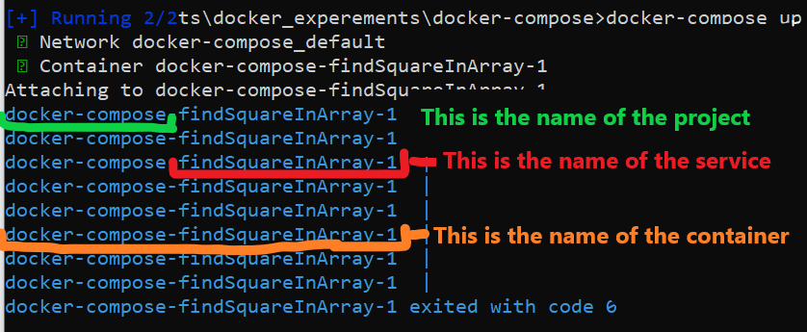

If you want to change the name of the project there is an option:

**docker-compose -p dimon up** ->it changes the name of the project to dimon, output will be:

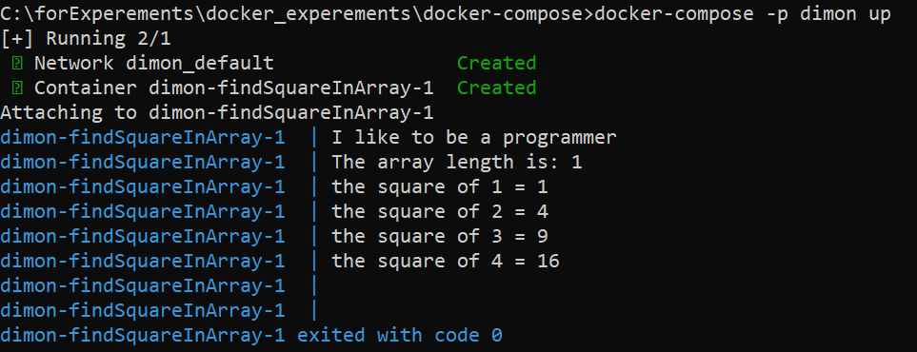

So we change the name of the project (-p stands for project). Now if we want to stop and remove container and all staff with it together, we need to enter **docker-compose -p dimon down.** If we enter just **docker-compose down** it will not remove the container because we did not specified the name of the project.